General:

Home ------------>Fixed
When I go to a reduced screen (anything other than full screen) the words on the pictures disappear.
I need the words to stay.
???
Need Value please change to Our Values
Buttons: Care Teams, Benefits/Services, Knowledge Tools ….these need to be the same darker blue
(Any blue button needs to be the dark blue and not the childlike blue)

Slide 1: ------------>Fixed
Add Picture:
CHANGE
Patient-Centered Care
To include not only the patient but the family unit with responsive, individualized care and support.

Slide 2: ------------>Fixed
Add Picture:
CHANGE
Interdisciplinary Approach
To provide the patient with holistic and multi-dimensional pursuit of end-of-life care.

Slide 3: ------------>Fixed
Add Picture:
CHANGE - maybe
Respect and Support
To the patient and family unit through their end-of-life journey and decision making process.

Slide 4: ------------>Fixed
Add Picture:
CHANGE
Providers of Consistency and Quality
To guide the Plan of Care to more effectively meet the individualized needs of the patient.

Testimonials: ------------>Fixed (not added last test)
“Thank you very much for the tender loving care you gave my mother. I know you comforted her in her time of need. Knowing that she is not suffering gives me comfort.” -P
“We are grateful for your kindness and compassion during my mom’s final week.” -H Family
“The family … would like to extend our beautiful gratitude to all who cared for our mother during her last days. We are truly grateful that our mother was met with much care and dignity. Thank you again, for all that you do!” -P Family
“Your kind caring attention to my mother was appreciated more than I can put into words.” -B

About Us ------------>Fixed
Good.
Add picture:
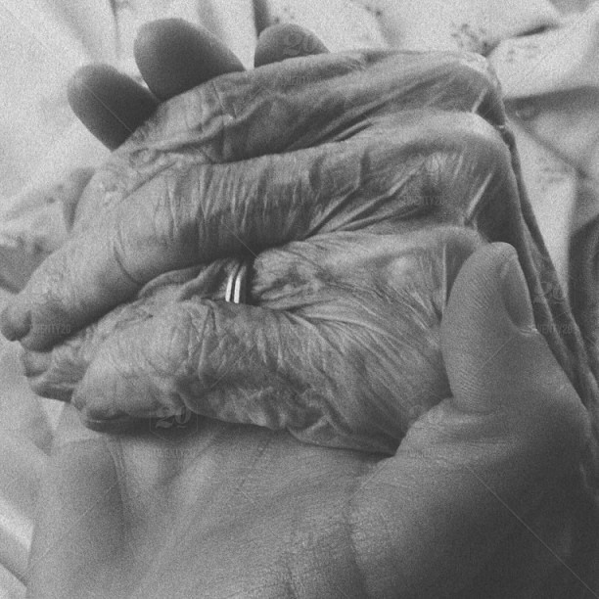
CHANGE

Care Teams ------------>Fixed
Main Page should have links for Interdisciplinary Team and Medical Professionals Team

No: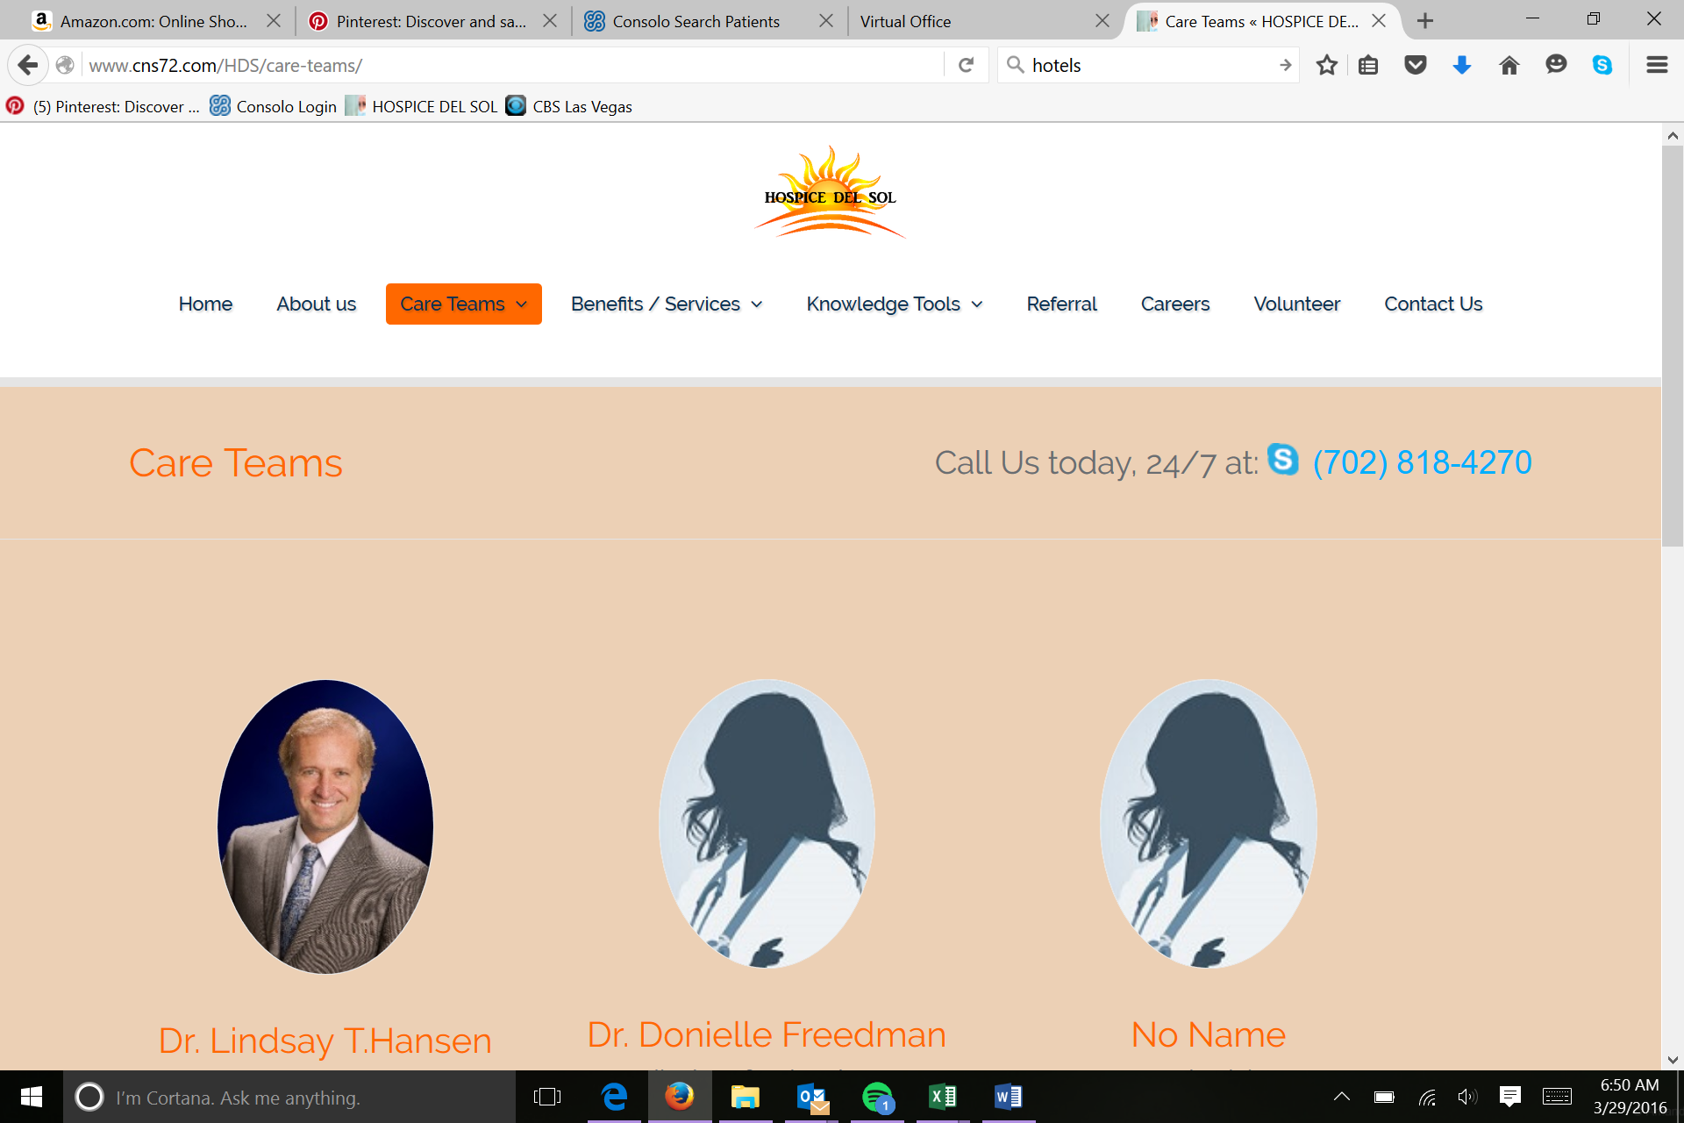
Example: (Interdisciplinary Team and Medical Professional Team should link to the respective pages)
Medical Professional Team
Interdisciplinary Team

Interdisciplinary Team
Add Picture:
Good
Medical Professionals Team
Add Picture:
Good.
Executive Team
Removed – Good!

Benefits / Services ------------>Fixed
Main page should have all service pages listed with link to page….not a break down of Level of Care
No: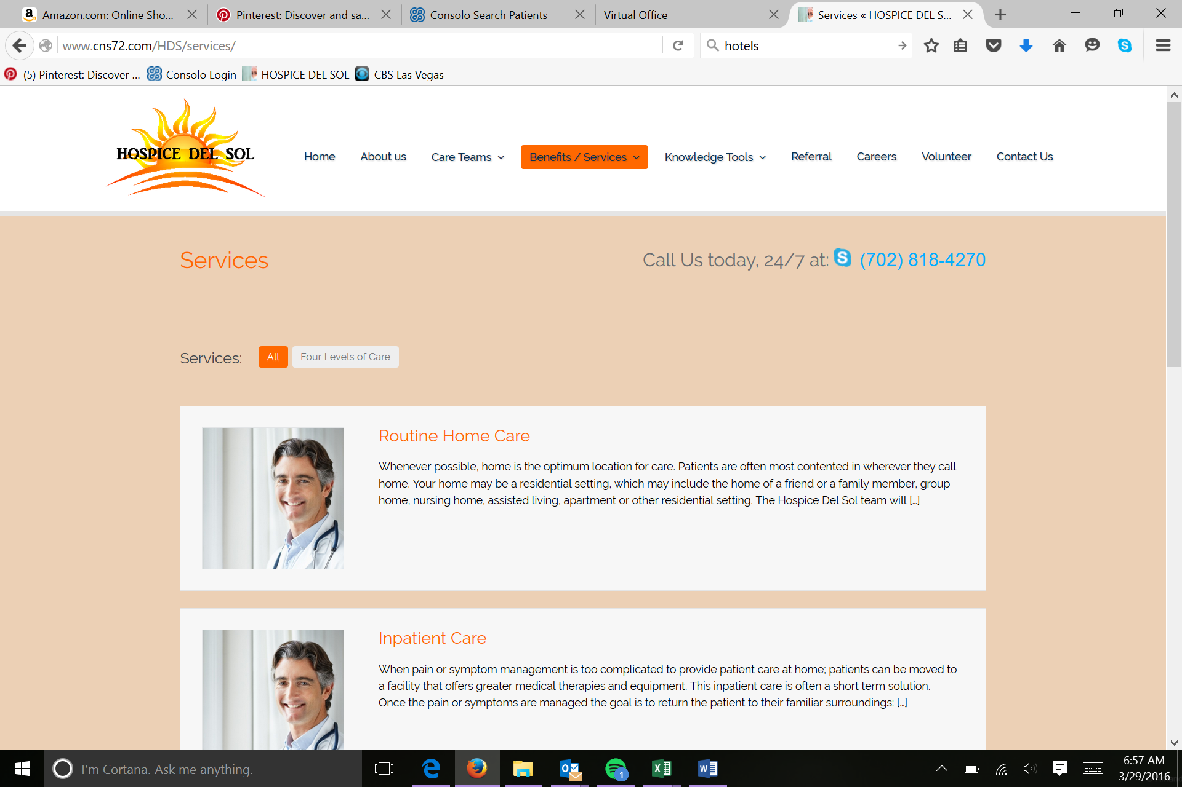

Example: (Early Referral Support, Levels of Care, Interdisciplinary, Social Service Education and Support, Medical Support, Therapy Services, Bereavement Services, Volunteers should all link to the respective pages)

Early Referral Support ------------>Fixed
Add: Button to “Referral”
Add Picture:
CHANGE
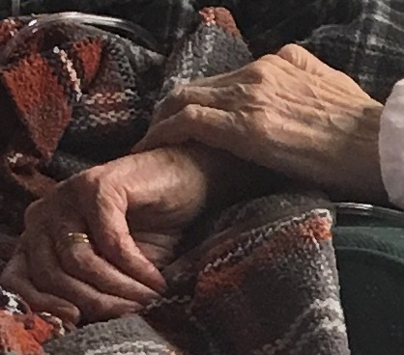
Palliative Advisors Teaching Healthcare Transitional care Education And Management
PATH TEAM
Levels of Care
Good.
Interdisciplinary -------->Fixed
When a person clicks on interdisciplinary from the “Benefits/Services” tab or main page or the “Care Teams” tab….all should link to the same page
This tab should like to the interdisciplinary team page under care teams.

Social Services Education and Support
Add Picture:
Good.
Medical Support ------------>Fixed
Add picture:
Button: Dark Blue
Therapy Services ------------>Fixed
Remove: Volunteer Button
Bereavement Services and Support
Add Picture:
Good.
Volunteers
Button: “Volunteer today!”

Knowledge Tools ------------>Fixed
This is great! Please make the links font larger ☺
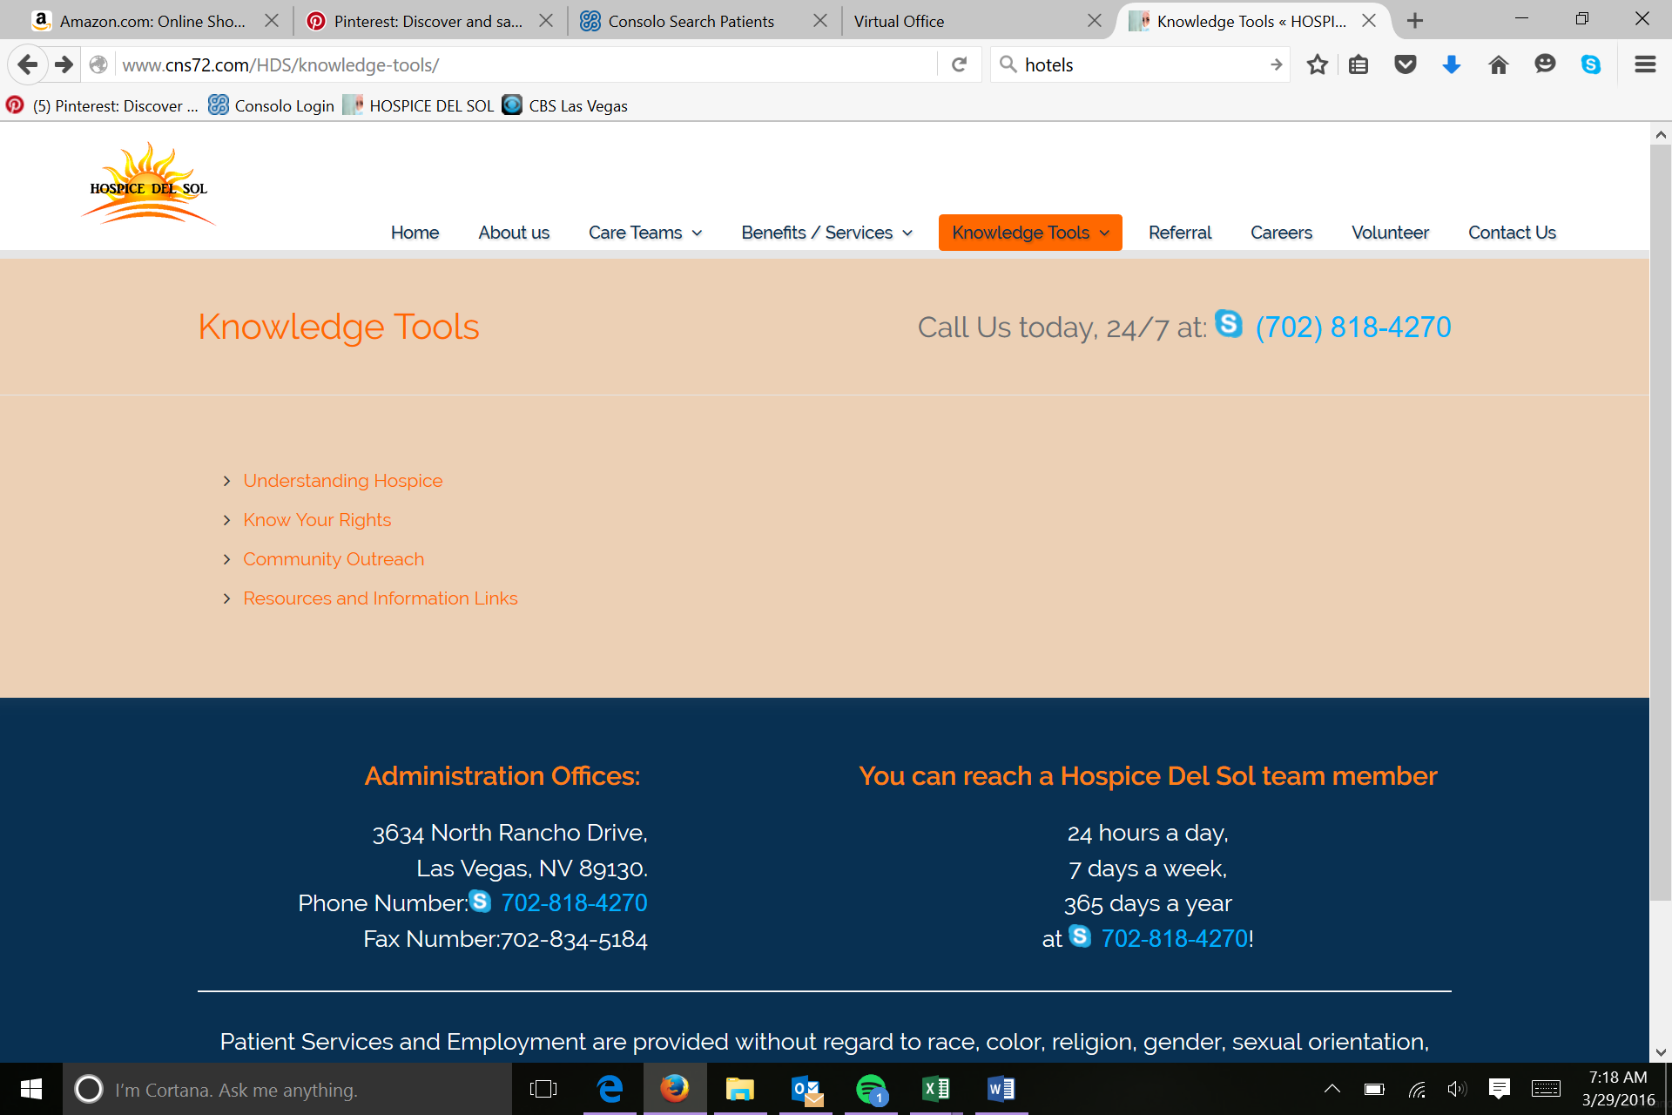
Understanding Hospice ------------>Fixed
Add Picture:
Make sure spacing is consistent
Know your Rights ------------>Fixed
Button: Dark Blue. “POLST” “DNR”
Add Picture:
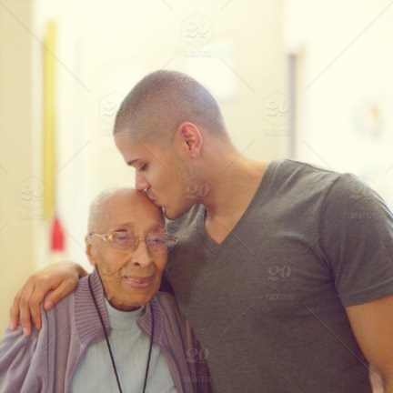
.
Community Outreach ----------->Fixed
Good!
Button: Dark Blue, “When Choosing at Hospice…”
Resources and Information
Good.
Referral ------------>Fixed
Change “Refer a patient to Hospice Del Sol!” to…..
Blue: Can we help you and your loved ones?
Instructions: change to comments
(This goes to info@hospicedelsol.com …correct?)
Careers ------------>Fixed
Add:
Blue: Do you want to become a Hospice Del Sol team member? Apply today!
>If you have additional questions or wish to speak with a Hospice Del Sol HR team member email us at careers@hospicedelsol.com.
>If you would prefer to submit a resume, please send document to careers@hospicedelsol.com.

Volunteer ------------>Fixed
Delete: “Contact Hospice Del Sol”
Under type, please add Several Types and Undecided
Contact us -------------->Fixed
Delete: “Contact Hospice Del Sol”
(This goes to info@hospicedelsol.com …correct?)

